29. Life History Phenomena *(Chapter 52)*

______________________________________________________________________________

I. Life History Strategies *(1226-1231)*

# A. Allocation of Resources

B. Evolution of Life History Characteristics

1. Measurement of fitness

2. Factors contributing to fitness

C. Examples of Life Histories

D. Demographic Issues

1. Likelihood of survival

2. Number and size of offspring

3. Parental care

4. Timing of reproduction

II. Survivorship *(1226-1227)*

A. Factors Affecting Survivorship

B. Survivorship in Natural Populations

1. Techniques for estimating survivorship

2. Life tables and survivorship curves

III. Fecundity and Parental Care *(1228-1230)*

A. Fecundity

1. Definition

2. Factors controlling fecundity

B. Parental Care

1. Definition

2. Passive parental care

3. Active parental care

C. Relationship Between Fecundity and Parental Care

D. Fecundity and Parental Care in Birds

1. Altricial versus precocial birds

2. Simultaneous incubation / adjustment of clutch size

3. Sequential incubation

4. Brood parasitism

IV. Timing of Reproduction *(1230-1231)*

A. Growth *versus* Reproduction

1. Determinate versus indeterminate growth

2. Evolutionary and ecological "decisions"

B. Survival Likelihood and Timing of Reproduction

29-1

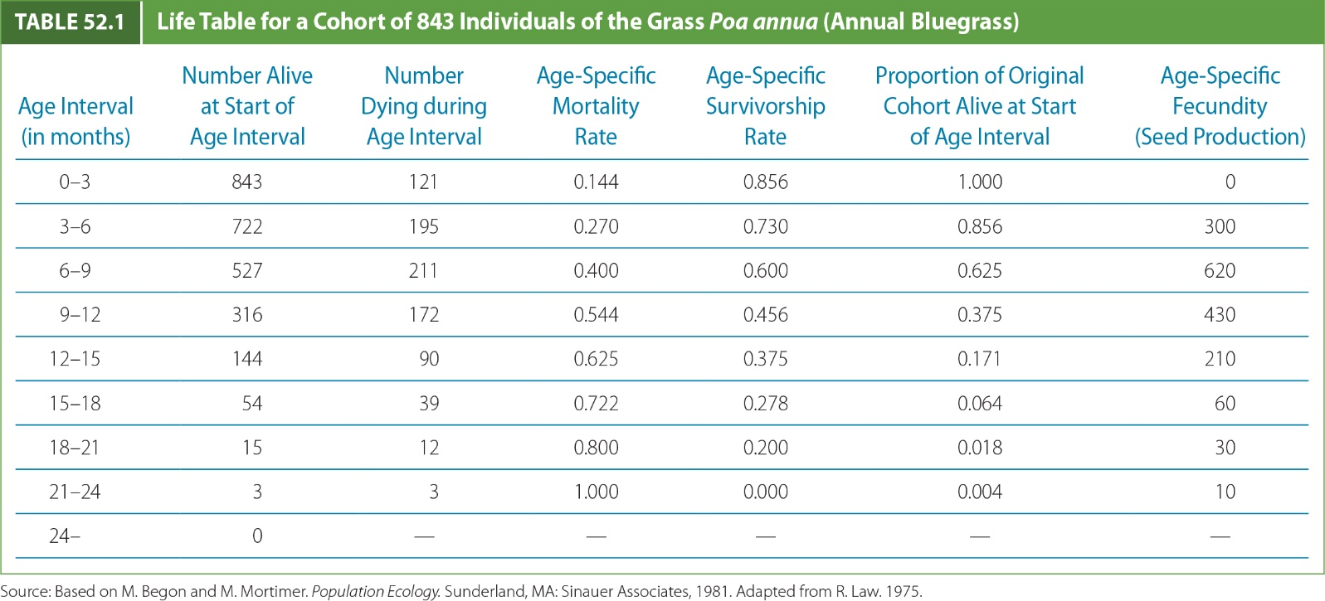

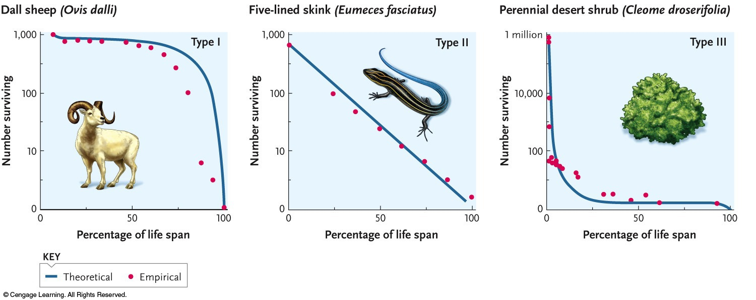

29-2

